<https://www.youtube.com/watch?v=zkZfxlBnbAA>

1. How many test scripts you author per day?

Ans: It is based on Complexity and number of test steps in that particular test case.

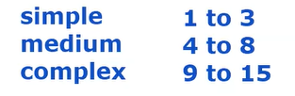

10 TCs, 6 to 7 TCs, 3 to 4 TCs

1. Till now how many TCs have you automated?

Ans: (on average 5 TCs per day) x (250 working days) x (Years of experience)

= 5 x 250 x 4 = 5000

But not every day we will automate, some times we may face build issues, some days go for planning or manual testing, gathering test data or maintenance phase so 5000/2 = 2000

Or Regression TCs = wtw = 400, maintained 90 TCs for one year

TCS = 50

1. 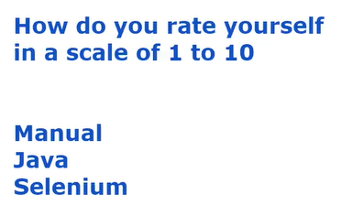

7,7,8

1. What are the components of Selenium?

4: RC,IDE, WebDriver, Grid (for parallel execution)

1. What exceptions do you get? **StringIndexOutOfBoundExeption**

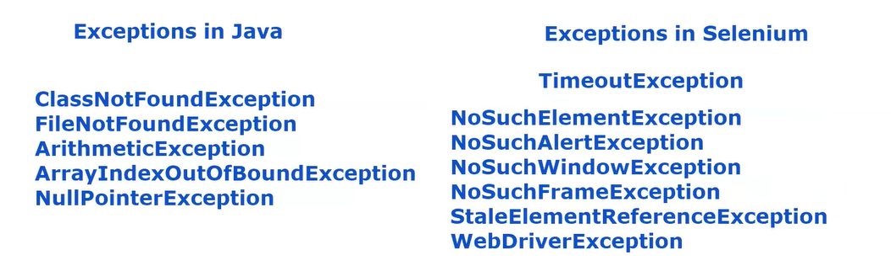

1. 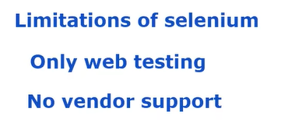

we only have community support as it is open source (not licensed)

1. Difference between findElement() and findElements()?

findElement – will find the first matching web element, return type is WebElement

if it does not find the element it will give NoSuchElementException

findElements – it will give list of Web Elements, return type is List<WebElement>

1. 

It is based on how many times we are going to execute those TCs. EX: Smoke and Regression

Not all Manual TCs can be or should be automated.

Business critical Test cases, i.e., those which are visible to client or end user.

Smoke TCs will be executed at least once per build.

Regression TCs will be executed every time when code changes are made to check whether everything is working as expected as per last sprint.

4 reasons why code changes are done:

1. New requirements are added
2. Existing requirements get modified
3. Obsolete or old requirements get deleted
4. Defect Fixes are made

Automate TCs based on ROI return on investment.

In the given budget what are the best TCs that can be automated (which are to be executed frequently.)

1. Not good candidates for automation?

Which are difficult

Which involves navigation between different applications (multiple applications are interlinked)

Which require MFA

1. 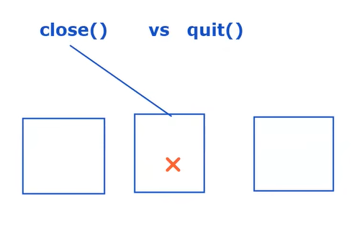

Close() will close only the current window

Quit() All the windows that are opened by the current driver will be closed